30.65: a) Just after the switch is closed the voltage 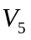 across the capacitor is zero and there is also no current through the inductor, so 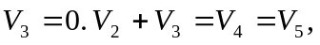 and since 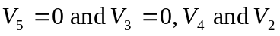 are also zero. 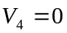 means 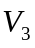 reads zero.
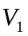 then must equal 40.0 V, and this means the current read by  is 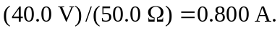
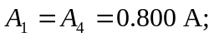 all other ammeters read zero.
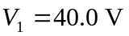 and all other voltmeters read zero.
b) After a long time the capacitor is fully charged so 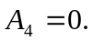 The current through the inductor isn’t changing, so 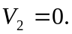 The currents can be calculated from the equivalent circuit that replaces the inductor by a short-circuit.:
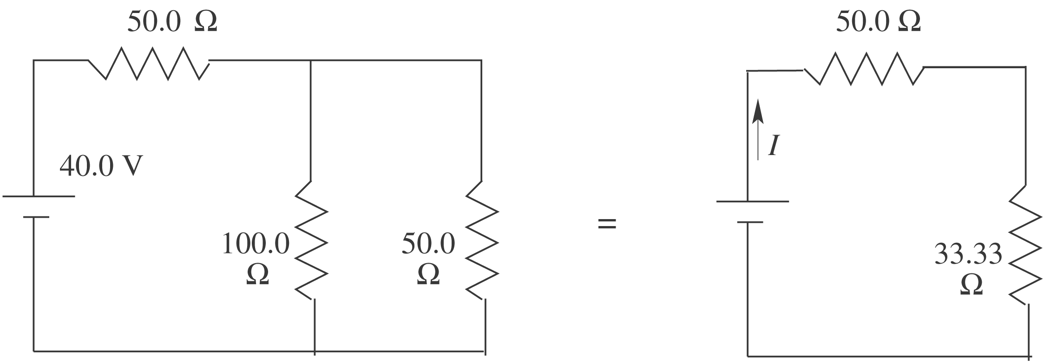
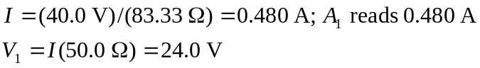
The voltage across each parallel branch is 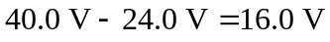
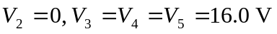
d) At t = 0 and 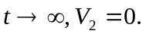 As the current in this branch increases from zero to 0.160 A the voltage 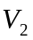 reflects the rate of change of current.
